 | Evolution Sails  Women on Water Weekend  7th – 9th March 2025 | 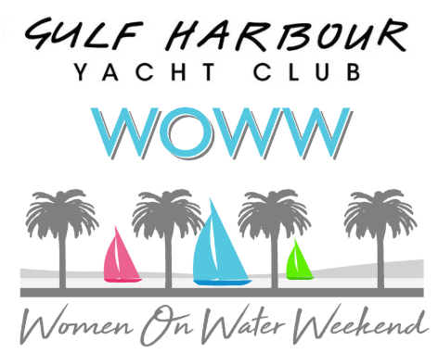

The Weekend’s Programme

FRIDAY 7th March
0900-1030 | - Registrations for all boat owners, skippers and crew  - Receive pre-paid meal tickets and shirts
1100 | - Formal welcome & meet boat owners & crew
1130 | - Meet at your boat and head out for a shake down sail and possibly anchor for lunch and a swim (BYO lunch)
1600 | - Return to club house for Familiarization Session – what to expect over the weekend
1800 | - Build a Burger Buffet (for those who have booked)
SATURDAY 8th March
0800-0900 | - Breakfast at GHYC (for those who have booked)  - Registrations for all boat owners, skippers and crew
0900 | - Race Officer Briefing (for all divisions)
1030 | - Race 1 pursuit format start for all divisions, followed by Spinnaker & non-spinnaker divisions - races 2 & 3 back-to-back. Harbour Course Division - 2 more pursuit format races
1700 | - Day 1 results & spot prizes - out on the deck weather permitting
1800 | - Dinner and Live Band (ticket only event – tables allocated)
SUNDAY 9th March
0800 | - Breakfast at GHYC (for those who have booked)
1030 | - Spinnaker & non-spinnaker divisions races 4 & 5 back-to-back  & Harbour Course 4
1500 | - Event Results, Prize giving and farewell

